14
Short-Term Weather Forecasting for Precision Agriculture in Jammu and Kashmir: A Deep-Learning Approach

Syed Nisar Hussain Bukhari and Sana Farooq Pandit
National Institute of Electronics and Information Technology (NIELIT), Srinagar, India

INTRODUCTION
Agricultural production serves as a primary source of economic develop- ment in any country, and weather forecasting (WF) directly or indirectly influences the yearly profitability or loss of agricultural production [1]. WF enables farmers to anticipate and prevent potential damages caused by intense weather phenomena, including reduced yields, misirrigation, erroneous crop selection, and inaccurate harvesting times. Unpredictable weather changes can significantly hinder agricultural progress for an extended period of time. The capacity to anticipate approaching snowfall, rainfall, heatwaves, and floods aids farmers in strategizing and subduing the devastating impacts of such events.
With the advancement of artificial intelligence (AI) in WF, the reliability and accuracy of predictions has significantly improved. Data-driven AI algorithms like neural networks (NN) can be employed to analyse historical weather data and forecast future trends and patterns in weather. These models also improve the accuracy of short-term weather predictions, aiding agriculturists to take informed decisions. Conversely, the performance of statistical techniques such as Autoregressive Moving Average (ARMA) and its variations relies on both the quality of the data and their capability to accurately represent time-series (TS) data exhibiting non-stationary pat- terns across different seasons [2]. The data-driven modeling systems can be

DOI: 10.1201/9781003485179-14 243

employed to decrease the computational requirements of Numerical Weather Prediction (NWP) while also accounting for the uncertainty pres- ent in observations and system noise [3]. This can be ascribed to the capacity of data-driven models to estimate the intrinsic patterns and dynamics of TS data, even without prior knowledge of the parameters. Specifically, Artificial Neural Networks (ANNs) can be employed for this objective owing to their adaptive characteristics and capacity to learn from previous knowledge [4]. These characteristics make ANNs appealing in diverse fields, particularly when dealing with intricate nonlinear phenomena present in datasets such as weather datasets. Different categories of NN, such as feedforward NN, NN employing back propagation, Recurrent Neural Networks (RNNs), and Long Short-Term Memory (LSTM), adopt a distinct approach to prediction, each offering a unique method for achieving accurate results.
To effectively handle weather data, RNN and LSTM models are consid- ered superior choices due to their ability to efficiently process TS data [5]. Conventional NNs lack the necessary power to capture long-term depen- dencies. As the number of layers increases, they are prone to encountering the vanishing gradient problem. On the other hand, Recurrent Neural Networks (RNNs) are well-suited for handling TS data with diverse tem- poral scales, allowing them to store long-term information. For the train- ing of RNN, a TS dataset consisting of daily records of minimum temperature (min temp), maximum temperature (max temp), and rainfall values has been acquired from the Indian Meteorological Department (IMD). This study aims to establish a predictive modeling framework for short-term WF in order to assist farmers in efficient agricultural resource management and plan their farming activities ahead of time. The model will utilize past values within a defined time step as input to forecast min temp, max temp, and rainfall values for the shorter number of days.

Contributions
The primary contributions of this study are summarized as follows:

- To reduce the direct and indirect economic load caused by to reli- ance of farmers on erroneous predictions of weather
- To proactively reduce potential damages in the agricultural sector resulting from severe weather situations
- To construct a deep-learning (DL) model specifically designed for short-term WF using TS data

- To generate precise weather predictions within a limited timeframe by utilizing localized weather data
- To construct a WF model that demonstrates strong adaptability to evolving trends in weather data and effectively handles extreme weather events while maintaining consistent performance

RELATED WORK
Various techniques based on both statistical methods and data-driven models have been devised over time to forecast weather conditions by predicting one or more weather-related parameters. Researchers [6] conducted a study to predict rainfall intensity using daily temperature, humidity, wind direction, wind speed, and cloud speed. The prediction models were built using Decision Tree (DT), Support Vector Regression (SVR), and Random Forest (RF), achieving an R2 score of 0.806, 0.900, and 0.980, respectively. In another study, researchers [7] trained differ- ent machine-learning models for rainfall prediction in order to sup- port precision agriculture in Sri Lanka. The models were trained using attributes like rain gauge, relative humidity, average temperature, wind speed, wind direction, solar radiation, and ozone concentration specific to the region of Sri Lanka. It was observed that RF performed best with an accuracy of 89.16%. In their work, researchers [8] combined machine- learning techniques with data mining techniques to develop a rainfall prediction model, and it was observed that Autoregressive Integrated Moving Average (ARIMA) models and NNs provide the best accuracy of 70.5%. In the last decade, RNNs have attracted substantial attention and seen significant progress because of their strong and influential modeling capabilities [9]. In a study, researchers [10] employed daily discharge and rainfall to forecast floods. The research findings suggested the potential use of LSTM, which is a variant of RNN, for the development and admin- istration of real-time flood warning systems. In their experimental study, researchers [1] concluded that the LSTM model outperforms the ARIMA model in predicting minimum and maximum temperature by a root mean squared error (RMSE) score of 1.04. The research carried out by Gumaste and Kadam [11] Placeholder Textemployed the Genetic Algorithm (GA) and Fast Fourier Transform (FFT) for future weather prediction using present data [11]. The models were subsequently deployed through mobile

apps to assist farmers in planning their pre- and post-agricultural tasks. To achieve precise weather forecasts for the Dellangu village of Indonesia, researchers developed a short-term weather prediction model utilizing ANNs to help farmers deal with their rice field problems [12]. Another research conducted a comparative analysis between ten base machine- learning regressors and an ensemble model [13]. The analysis suggested that the ensemble model performed better than base models for predicting rainfall, relative humidity, and maximum and minimum temperature. In order to reduce the cost of agricultural frost damage, researchers trained machine-learning models like the convolutional neural network, deep neural network, and RF to predict frost events [14]. The research estab- lished that soil temperature is a crucial factor when making predictions beyond 24 hours, whereas for shorter-term forecasts, most of the relevant information is derived from other temperature-related parameters.

PROPOSED WORK
This study presents an innovative and lightweight WF model specifically designed for accurate short-term predictions of temperature and rainfall in Jammu and Kashmir (J&K). The model is designed to be compatible with stand-alone PCs and can be readily implemented in the geographi- cal region J&K. The proposed system utilizes an advanced DL technique known as RNN that is suitable for sequential data and can enhance the accuracy of the predictions. The following subsection provides an elabo- rate explanation of the RNN model.

Recurrent Neural Network
A traditional RNN [15] can be thought of as a variation of a feedforward NN that possesses an internal memory component to process the input sequences. RNNs have the ability to learn dependencies from previous terms and predict cumulative measures from variable-length sequences, which include a time component. RNNs are particularly useful for devel- oping prediction models using long-term TS datasets, which can be useful in WF. Unlike traditional deep NN that assume inputs and outputs are unrelated to one another, RNNs generate outputs that are influenced by preceding elements within the sequence. For that, RNNs utilize feedback

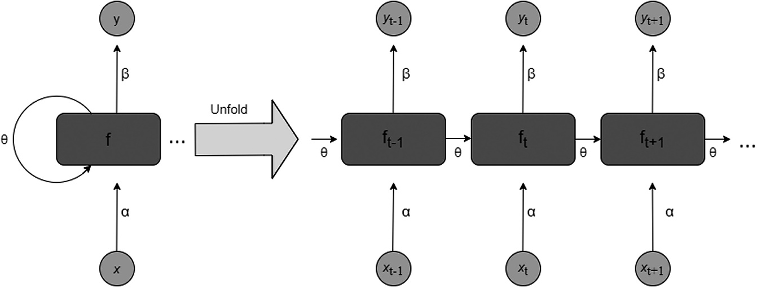

FIGURE 14.1
Working of RNN.

loops to leverage the output from one time step as input for the subsequent step. By maintaining information in a sequential manner, the input of the RNN at each time step incorporates both the data from the current time step in the sequence and the preceding information passed through the feedback loop. The recurrent nature of an RNN stems from its consistent application of the same function to compute the output for each input, with the output being influenced by previous calculations.
Figure 14.1 illustrates a basic RNN architecture in which x_{t} to x_{t+1} repre- sent the inputs for each sequence, and y_{t} to y_{t+1} represent the correspond- ing outputs produced for each sequence. It is evident that all the inputs are interconnected, with each connection denoted by a single RNN cell. The terms f_{t−1} to f_{t+1} refer to hidden states, and θ represents the weight of hidden states; α signifies the weight of the current input state; β represents the weight at the output state. In contrast to traditional feedforward NNs where weights are distinct for each node, RNNs utilize shared parameters across the layers, implying that within each layer of the RNN, the same weight parameter is applied. However, these shared weights are still updated during the backpropagation and gradient descent processes to enable effective reinforcement learning. The functioning of RNN can be explained in the following steps:
For a sequence of data points x, denoted as x = [x_{t} ₋ ₁, x_{t}, x_{t} ₊ ₁…], where x_{t}
represents the input at a specific time step “t” within the sequence:

- The hidden state at time step “t”, denoted as f_{t}, is calculated by com- bining the current input x_{t}with the previous hidden state f_{t} ₋ ₁. This computation is expressed as

f_{t} = σ (α x_{t} +θ f_{t−1} ),

where σ represents the activation function applied to the sum of weighted inputs; α represents the weight matrix for the connections from the input to the hidden state; θ represents the weight matrix for the connections within the hidden state.
- The output y_{t} at time step “t” can be computed using the hidden state:
y_{t} = σ (βf_{t} )
where β is the weight matrix for the hidden-to-output connections.
The activation function is a mathematical operation used to incorporate non-linearity into NN, allowing them to effectively learn intricate data patterns and make nonlinear changes to the input data. In RNNs, the acti- vation function is exclusively applied to the hidden layers since the input layer solely holds the input data and does not undergo any calculations. Additionally, the output of the RNN, which represents the network’s pre- diction or generated output at each time step, can also undergo an activa- tion function to convert the raw output into a preferred range or format based on the specific task or problem being tackled. Without the presence of nonlinear activation functions, a neural network with multiple hidden layers would essentially resemble a large-scale linear regression model and would be unable to effectively learn intricate and complex patterns from real-world data. Commonly used activation functions are Rectified Linear Unit (ReLU), tanh, Sigmoid, and Softmax.

      - Backpropagation through Time (BPTT)
BPTT [16] is an iterative training method utilized specifically for RNNs. It extends the standard backpropagation algorithm, commonly employed for training feedforward NN, and incorporates the temporal aspect of RNNs by allowing gradients to propagate backward across time, considering the sequential nature of the TS data. In RNN, the hidden state of the network at each time step is influenced by both the current input and the output from the previous hidden state. This gives rise to a chain of dependencies that stretches back in time, allowing BPTT to unfold the RNN over time. A simplified breakdown of the steps involved in BPTT is given next:

For a sequence of data points x, denoted as x = [x_{t} ₋ ₁, x_{t}, x_{t} ₊ ₁…], where x_{t}
represents the input at a specific time step “t” within the sequence.

        - The hidden state at time step “t”, denoted as f_{t}, is calculated by com- bining the current input x_{t}with the previous hidden state f_{t} ₋ ₁. This computation is expressed as
f_{t} = σ (α x_{t} +θ f_{t−1} ),
Where σ, α, and θ have the usual meanings.

        - The loss function, such as mean squared error (MSE) or cross- entropy loss, is applied to calculate the loss at each time step. We can represent the loss at a specific time step “t” as l_{t}.
The gradients of the loss with respect to the parameters of the net- work are calculated from the final time step. Subsequently, these gra- dients are propagated in a backward direction across previous time steps. The gradient at time step “t,” which signifies the impact of the loss on the hidden state at “t” can be represented as:
∂l_{t}
∂f_{t}

        - The gradients are accumulated at each step as they propagate through time, ensuring that dependencies between different time steps are captured effectively. Accumulated gradients are represented as follows.
∂l
∂f_{t}

        - The parameters of the network are updated by utilizing optimiza- tion algorithms such as Adam, SGD and RMSprop. The parameter update for each weight can be computed as
Δw = −η ∗∑ ∂l ,
∂w
where ∆w is the update in weight, and η is the learning rate.

EXPERIMENTS
Figure 14.2 illustrates the comprehensive process of modeling in detail. The experimentation initiates with the data collection and data prepro- cessing phase, which is elaborated in the subsequent section. Following that, the process encompasses model configuration, training, comparison, and evaluation. The final step of the experimentation involves assessing and contrasting the performance of the trained models.

Data Collection
This study utilizes real meteorological data obtained from the IMD web- site [17], specifically from weather stations in Jammu, Srinagar, and Leh. The dataset for each weather station consists of a daily TS comprising 8,401 data points, spanning from January 1, 2010, to December 31, 2022. The dataset includes various weather variables, including rainfall, minimum temperature, and maximum temperature. Rainfall values are measured

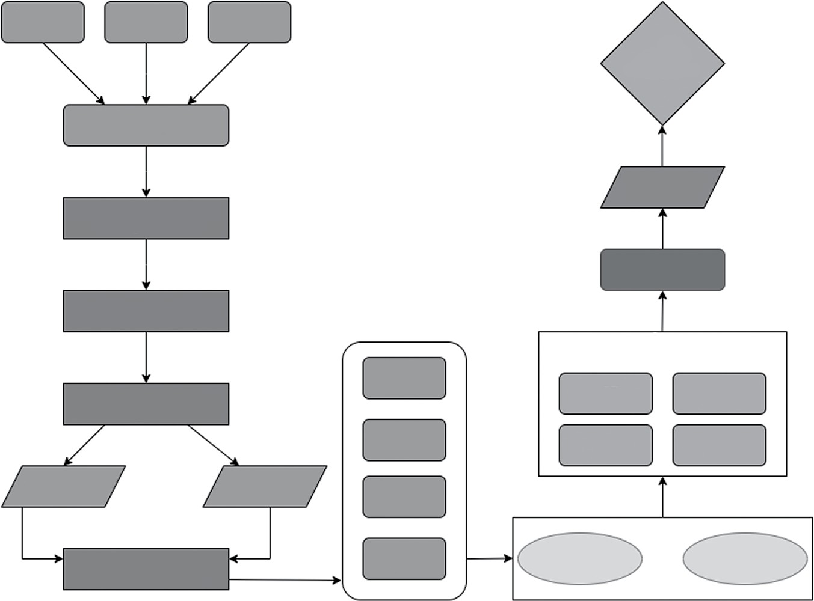
Minimum Maximum temperature temperature
Rainfall
Model deployment
Time-seris dataset
Performance assessment
Data smoothing (exponential moving average)
Hyperparameter Tuning
Data differencing (order=1)
Error evaluation
Data normalization (MinMax scaling)
Train-test split
Train input data
MSE
RMSE
Train input data
MAE
MAPE
Training data
Training data
Train output data
Model training
Dataset splitting for input and output sequence
Test output data
Recurrent neural network (RNN)
Long short-term memory (LSTM)
FIGURE 14.2
Illustration of modeling.

in millimeters (mm), while temperature variables are recorded in Celsius. These specific meteorological features are chosen because they provide valuable insights into the current weather conditions at a particular loca- tion and time. The selection of these features aims to capture the state of the weather accurately. In this study, these three meteorological features are utilized as input variables for predicting temperature.

Data Preprocessing
The experiment conducted on real data necessitated several preprocessing steps to accurately reflect the performance of the model. In the beginning, smoothing of data has been performed to reduce noise and fluctuations and make underlying patterns and trends more evident. Data has been smoothened using the Exponential Moving Average (EMA) technique. EMA [18] is the weighted average value where weights are decreased grad- ually such that more importance is given to recent data points as com- pared to the historical ones, or vice versa. EMA changes at a faster rate and is more sensitive to the data points. Mathematically, the EMA of a data point can be calculated using Equation 14.1.

EMA
= ⎧⎪
x₀ t = 0
. (14.1)

^{t} ⎨⎪α x_{t} + (1−α )EMA_{t−1}t > 0
⎩

where α is a smoothing factor, and its value lies between 0 and 1. It rep- resents the weight applied to the very recent period. For this study, the value of α has been kept at 0.5. To make the TS stationary, differencing of order one has been performed on the weather dataset. Differencing entails computing the differences between consecutive observations by subtracting the previous value from the current value. The purpose of differencing is to eliminate the underlying trend and isolate the specific changes or fluctuations present in the data. For the final stage of prepro- cessing, data has been normalized using the MinMax scaling technique because the values of different variables in the dataset have different units and lie in multiple ranges. Mathematically, MinMax scaling is repre- sented by Equation 14.2.
X_{t} = Xt − Xmin , (14.2)
Xmax − Xmin

where X_{t} represents the data point at time “t” in TS and X_{max} and X_{min} rep- resent maximum and minimum data points in the sequence, respectively. Normalized data allows models to generalize well on new and unseen data. Additionally, activation functions in RNN and LSTM neurons work more effectively on normalized data. The dataset has been divided into a training set and a testing set, with proportions of 0.8 and 0.2, respectively. Each weather station’s training dataset consists of 6,720 rows containing weather data from January 1, 2000, to May 25, 2018, while the testing data- set contains 1,680 rows spanning from May 26, 2018, to December 31, 2022. Input and output sequences were obtained using the moving win- dow algorithm and a window size of seven. Both input and output
sequences contain three features.

Model Configuration and Training
The proposed models have been trained using two distinct configurations: Single Input Single Output (SISO) and Multiple Input Multiple Output (MIMO) [19]. SISO is a forecasting arrangement wherein a single input variable is fed into the network to forecast the future values of the same variable as output. On the other hand, in MIMO, multiple variables are fed into the network in order to predict the same variables as output. Using this configuration, only one model is required per weather station to predict all the future values, while in SISO, three different models are needed for each weather station to forecast three weather parameters. Therefore, three RNN models were trained and evaluated using the MIMO configuration for three distinct weather stations. In addition, a total of nine RNN models were both trained and tested in SISO configuration to forecast three tempera- ture variables across three weather stations. Both configurations have been trained on different sets of hyperparameters of RNN. Hyperparameters are specific values that must be defined prior to model training and are not subject to learning or adjustment during the model training process. The hyperparameters tuned in this study include the number of epochs, batch size, optimization algorithms, and activation functions. The technique chosen for tuning hyperparameters is GridSearchCV, which automates the process of trying various hyperparameter configurations. It thoroughly explores a pre-defined grid of hyperparameter values to identify the combi- nation that produces the highest model performance. For the RNN model, the number of epochs defines how many times the model will be trained

on an entire dataset [20–23]. During each epoch, the model goes through one forward pass (input to output) and one backward pass (adjusting weights based on gradients) for all training samples. Using a smaller num- ber of epochs leads to increased error loss, while a larger number of epochs may cause overfitting. The models have been trained for a range of 50–300 epochs. The batch size refers to the number of training samples processed together by the model in one forward and backward pass, allowing the model to update the weights after processing a group of samples. Using a larger batch size during model training comes with higher computational costs, while a smaller batch size introduces noise in the model. Hence, training experiments have been conducted with batch sizes of 16, 32, 64, and 128 to find the optimal configuration. The choice of the optimization algorithm impacts both the speed at which the model reaches its optimal solution and its ability to generalize effectively to unseen data. In order to identify the most suitable optimization algorithm, the models underwent training using Adam, SGD, and RMSprop optimizers. For selecting the optimal activation function, models have been trained on tanh, ReLU, and sigmoid activation functions.

Model Evaluation
The models have been repeatedly trained on training data and evaluated on testing data. For evaluating TS regression models, the commonly used metrics are mean absolute error (MAE), MSE, RMSE, and mean abso- lute percentage error (MAPE), which are calculated by using Equations
14.3–14.6 [24–26].

MAE = ∑ y_{t} − y´ t i =1
N
(14.3)

^{N} ⎛ ⎞²

MSE = ∑⎜ y_{t} − y´ t ⎟
⎝ ⎠
i =1
(14.4)

RMSE =
∑
N
⎛
⎞2
i =1 ⎝
⎜ y_{t} − y´ t ⎟
⎠
n
(14.5)

N
MAPE = ∑
y_{t} − y`i
y
i =1 i
(14.6)

where y_{t} and y´ t are the actual and predicted values of temperature vari-
ables at time step “t.”

RESULTS AND DISCUSSION
As mentioned in Section 14.3, the RNN model has been trained using dif- ferent sets of hyperparameters and tested using various evaluation met- rics. For each station, it has been observed that the RNN model performs noticeably better in the SISO configuration than the MIMO configuration. The values of different accuracy metrics for RNN models are listed in Table
14.1 for all weather stations. Tables 14.2–14.4 list the accuracy metrics of the RNN model in SISO configuration for Jammu, Srinagar, and Leh, respec- tively. These findings indicate that the variables present in weather data are relatively univariate and do not possess strong interdependencies between them. Such relationships can be adequately represented using a single input variable to forecast a single output variable [27–29].

CONCLUSION AND FUTURE SCOPE
This study highlights the importance of choosing regional data in build- ing a reliable WF model and tackling the WF problem by focusing on

TABLE 14.1
Model Performance in MIMO Configuration for all the Stations
Metrics | Corresponding Value for Jammu Station | Corresponding Value for Srinagar Station | Corresponding Value for Leh Station
MAE | 0.0636 | 0.1048 | 0.8543
MSE | 0.0401 | 0.0455 | 0.0411
RMSE | 0.1011 | 0.1555 | 0.1344
MAPE | 0.3990 | 0.4398 | 0.3229

TABLE 14.2
Model Performance in SISO Configuration for Jammu Station
Temperature Variables | Tmin | Tmax | Rainfall
MAE | 0.0751 | 0.0690 | 0.0124
MSE | 0.0095 | 0.0095 | 0.0257
RMSE | 0.0977 | 0.0091 | 0.0006
MAPE | 0.1863 | 0.1683 | 0.1229

TABLE 14.3
Model Performance in SISO Configuration for Srinagar Station
Temperature Variables | Tmin | Tmax | Rainfall
MAE | 0.0658 | 0.0696 | 0.0210
MSE | 0.0073 | 0.0926 | 0.0018
RMSE | 0.0854 | 0.0085 | 0.0429
MAPE | 0.1436 | 0.1696 | 0.1368

TABLE 14.4
Model Performance in SISO Configuration for Leh Station
Temperature Variables | Tmin | Tmax | Rainfall
MAE | 0.0666 | 0.0085 | 0.0640
MSE | 0.0075 | 0.0015 | 0.0078
RMSE | 0.0866 | 0.0393 | 0.0887
MAPE | 0.1547 | 0.0588 | 0.1623

achieving precise forecasts without requiring substantial computational resources, in contrast to NWP methods. To resolve this, a lightweight DL-based prediction model has been proposed to ensure accurate short- term WF. The suggested model is capable of operating independently on a single computer unit and can be readily implemented in the geographical area of J&K. In future, more variables like wind speed, humidity, and pres- sure could be incorporated into the process of model training to provide a more diverse weather forecast. The results also showed that SISO per- formed better than MIMO configurations; however, that would require three different models to predict three weather parameters as output. In future experiments, MIMO configurations could be further optimized to enhance both performance and efficiency simultaneously.

REFERENCES
- Z. Prathyusha, T. Savya, N. Alex, and C. Sobin, “A Method for Weather Forecasting Using Machine Learning,” in 2021 5th Conference on Information and Communication Technology, CICT 2021, Institute of Electrical and Electronics Engineers Inc., 2021. doi: 10.1109/CICT53865.2020.9672403
- S. Poornima, and M. Pushpalatha, “Prediction of Rainfall Using Intensified LSTM Based Recurrent Neural Network with Weighted Linear Units,” Atmosphere (Basel), vol. 10, no. 11, Nov. 2019. doi: 10.3390/atmos10110668
- M. Hayati, and Z. Mohebi, “Application of Artificial Neural Networks for Temperature Forecasting”, International Science Index, Electrical and Computer Engineering, vol. 1, no. 4, pp. 662–666, 2007.
- F. Kratzert, D. Klotz, C. Brenner, K. Schulz, and M. Herrnegger, “Rainfall-Runoff Modelling Using Long Short-Term Memory (LSTM) Networks,” Hydrology and Earth System Sciences, vol. 22, no. 11, pp. 6005–6022, Nov. 2018. doi: 10.5194/hess-22-6005-
2018
- T. Kashiwao, K. Nakayama, S. Ando, K. Ikeda, M. Lee, and A. Bahadori, “A Neural Network-Based Local Rainfall Prediction System Using Meteorological Data on the Internet: A Case Study Using Data from the Japan Meteorological Agency,” Applied Soft Computing Journal, vol. 56, pp. 317–330, Jul. 2017. doi: 10.1016/j.asoc.2017.03.015
- V. P. Tharun, R. Prakash, and S. R. Devi, “Prediction of Rainfall Using Data Mining Techniques,” in Proceedings of the International Conference on Inventive Communication and Computational Technologies, ICICCT 2018, Institute of Electrical and Electronics Engineers Inc., Sep. 2018, pp. 1507–1512. doi: 10.1109/ICICCT.2018. 8473177
- J. S. A. N. W. Premachandra, and P. P. N. V. Kumara, “A Novel Approach for Weather Prediction for Agriculture in Sri Lanka Using Machine Learning Techniques,” in Proceedings - International Research Conference on Smart Computing and Systems Engineering, SCSE 2021, Institute of Electrical and Electronics Engineers Inc., Sep. 2021, pp. 182–189. doi: 10.1109/SCSE53661.2021.9568319
- U. Shah, S. Garg, N. Sisodiya, N. Dube, and S. Sharma, “Rainfall Prediction: Accuracy Enhancement Using Machine Learning and Forecasting Techniques,” in PDGC 2018
- 2018 5th International Conference on Parallel, Distributed and Grid Computing, Institute of Electrical and Electronics Engineers Inc., Dec. 2018, pp. 776–782. doi: 10.1109/PDGC.2018.8745763
- L. C. Jain and L. R. Medsker, Recurrent Neural Networks, 1999. doi: 10.1201/ 9781420049176
- X. H. Le, H. V. Ho, G. Lee, and S. Jung, “Application of Long Short-Term Memory (LSTM) Neural Network for Flood Forecasting,” Water (Switzerland), vol. 11, no. 7, 2019. doi: 10.3390/w11071387
- S. S. Gumaste and A. J. Kadam, “Future Weather Prediction Using Genetic Algorithm and FFT for Smart Farming.” 2016 International Conference on Computing Communication Control and automation (ICCUBEA), Pune, India, 2016, pp. 1–6. doi: 10.1109/ICCUBEA.2016.7860028
- F. Najib and I. W. Mustika, “Weather Forecasting Using Artificial Neural Network for Rice Farming in Delanggu Village,” in IOP Conference Series: Earth and Environmental Science, Institute of Physics, 2022. doi: 10.1088/1755-1315/1030/1/012002

- C. Nyasulu, A. Diattara, A. Traore, A. Deme, and C. Ba, “Towards Resilient Agriculture to Hostile Climate Change in the Sahel Region: A Case Study of Machine Learning- Based Weather Prediction in Senegal,” Agriculture (Switzerland), vol. 12, no. 9, Sep. 2022. doi: 10.3390/agriculture12091473
- H. Kerner, M. Alamaniotis, and C. J. Talsma, “Frost Prediction Using Machine Learning and Deep Neural Network Models.”
- S. Hochreiter, and J. Schmidhuber, “Long Short-Term Memory,” Neural Computation, vol. 9, no. 8, pp. 1735–1780. 1997. doi: 10.1162/neco.1997.9.8.1735
- P. J. Werbos, “Generalization of Backpropagation with Application to a Recurrent Gas Market Model,” Neural Networks, vol. 1, no. 4, pp. 339–356, 1988. doi: 10.1016/ 0893-6080(88)90007-X
- Home. (n.d.). Accessed: Aug. 07, 2023. https://data.gov.in/catalog/climatology- data-important-cities-0
- “Welles Wilder - New Concepts in Technical Trading Systems | PDF | Algorithmic Trading | Financial Economics.” Accessed: Aug. 09, 2023. [Online]. Available: https://www.scribd.com/doc/53093880/Welles-Wilder-New-Concepts-in- Technical-Trading-Systems#
- F. K. Oduro-Gyimah, and K. O. Boateng, “Forecasting Abilities of MIMO and SISO Neural Networks: A Comparative Study Using Telecommunication Traffic Data,” in Proceedings - 2019 International Conference on Computing, Computational Modelling and Applications, ICCMA 2019, Institute of Electrical and Electronics Engineers Inc.,
Mar. 2019, pp. 81–86. doi: 10.1109/ICCMA.2019.00020
- S. N. H. Bukhari, J. Webber, and A. Mehbodniya, “Decision Tree Based Ensemble Machine Learning Model for the Prediction of Zika Virus T-Cell Epitopes as Potential Vaccine Candidates,” Scientific Reports, vol. 12, pp. 7810, 2022. doi: 10.1038/ s41598-022-11731-6
- G. S. Raghavendra, S. Shyni Carmel Mary, Purnendu Bikash Acharjee, V. L. Varun, Syed Nisar Hussain Bukhari, Chiranjit Dutta, and Issah Abubakari Samori, “An Empirical Investigation in Analysing the Critical Factors of Artificial Intelligence in Influencing the Food Processing Industry: A Multivariate Analysis of Variance (MANOVA) Approach,” Journal of Food Quality, vol. 2022, Article ID 2197717, 7 pages, 2022. doi: 10.1155/2022/2197717
- S. N. H. Bukhari, A. Jain, E. Haq, A. Mehbodniya, and J. Webber, “Ensemble Machine Learning Model to Predict SARS-CoV-2 T-Cell Epitopes as Potential Vaccine Targets,” Diagnostics, vol. 11, no. 11, 1990. MDPI AG. Retrieved from doi: 10.3390/ diagnostics11111990
- Sunil L. Bangare, Deepali Virmani, Girija Rani Karetla, Pankaj Chaudhary, Harveen Kaur, Syed Nisar Hussain Bukhari, and Shahajan Miah, “Forecasting the Applied Deep Learning Tools in Enhancing Food Quality for Heart Related Diseases Effectively: A Study Using Structural Equation Model Analysis,” Journal of Food Quality, vol. 2022,
Article ID 6987569, 8 pages, 2022. doi: 10.1155/2022/6987569
- C. M. Anoruo, S. N. H. Bukhari, and O. K. Nwofor, “Modeling and Spatial Characterization of Aerosols at Middle East AERONET Stations,” Theoretical and Applied Climatology, vol. 152, pp. 617–625, 2023. doi: 10.1007/s00704-023-04384-6
- F. Masoodi, M. Quasim, S. Bukhari, S. Dixit, and S. Alam, Applications of Machine Learning and Deep Learning on Biological Data, CRC Press, 2023.

- S. N. H. Bukhari, A. Jain, and E. Haq, “A Novel Ensemble Machine Learning Model for Prediction of Zika Virus T-Cell Epitopes,” in Gupta, D., Polkowski, Z., Khanna, A., Bhattacharyya, S., and Castillo, O. (Eds.), Proceedings of Data Analytics and Management. Lecture Notes on Data Engineering and Communications Technologies, vol 91. Springer, Singapore, 2022. doi: 10.1007/978-981-16-6285-0_23
- S. N. H. Bukhari, F. Masoodi, M. A. Dar, N. I. Wani, A. Sajad, and G. Hussain, “Prediction of Erythemato-Squamous Diseases Using Machine Learning” in Auerbach Publications eBooks, pp. 87–96, 2023. doi: 10.1201/9781003328780-6
- S. N. H. Bukhari, A. Jain, E. Haq, A. Mehbodniya, & J. Webber, “Machine Learning Techniques for the Prediction of B-Cell and T-Cell Epitopes as Potential Vaccine Targets with a Specific Focus on SARS-CoV-2 Pathogen: A Review,” Pathogens, vol. 11, no. 2, p. 146, 2022. MDPI AG. doi: 10.3390/pathogens11020146
- S. Nisar, H. Bukhari, and M. A. Dar, “Using Random Forest to Predict T-Cell Epitopes of Dengue Virus,” Advances and Applications in Mathematical Sciences, vol. 20, no. 11,
pp. 2543–2547, 2021

